National Congress of Black Women, Inc./Jacksonville Chapter
ncbwjacksonvillechapter@gmail.com
ladygj839@gmail.com
nationalcongressbw.org
904-432-6182/904-844-5447

September 18, 2020

Dear Members of the Charter Commission,
Thank you for your commitment, dedication, and time in preparing recommendations for amendments to the City Charter to the City Council and the Duval Legislative Delegation.
In reviewing the information regarding the meetings and the solicitations of topic ideas from its membership and from the general public, I find that your listing of heard presentations did not include all of the people who spoke and gave presentations and the people who spoke at the town hall meetings.
It concerns me of your lack of being inclusive on your introductory page of who participated in these historical meetings. You say that you heard presentations and initiated town hall meetings, yet, on your listing of speakers, all speakers are not listed and the people from the community, who spoke at the town hall meetings, are not included (Page 3 of your introduction).
I find this to be extremely insulting to everyone who took time out from their schedule to appear at these meetings to express their concerns, recommendations, and/or suggestions. The practice of ‘systemic exclusion/Inequality’ is unacceptable. When the Mayor was running for office, he spoke about ‘One Jacksonville,’ but there are many examples of ‘Two Cities,’ not ‘One Jacksonville.’ This “…involves the lack of or denial of resources, rights, good, and services, and the inability to participate in the normal relationships and activities, available to the majority of people in society, whether in economic, social, cultural or political arenas.” (University of Ottawa-Social Exclusion Theory). This is the reason why so many people do not trust the government. It should not matter if it is over one hundred people to be listed. Everyone who spoke should be listed on your introductory page. This is history and from your introductory page, it appears as if only a few people had presentations. That does not present a true picture of who actually spoke at these meetings. It appears as if you were very selective in listing certain individuals on this list. Also, I did not see the names of the people who spoke at the town hall meetings. For the sake of the Jacksonville community, everyone should have been listed. Whether the Commission liked or disliked what the participants had to say, they should have been included.
We must remember that from these recommendations there will be written policies and from these policies, there will be implementations of laws that will impact ‘ALL’ citizens of Jacksonville.
In respect to everyone involved, I suggest that your short list of participants be changed to ‘include’ everyone who spoke as your invited guess; those individuals who spoke at your meetings, and everyone who spoke at the town hall meetings. By doing it this way, the right way, it will show to the public, the Jacksonville community, unity, and real community involvement.
Thank you for your time and cooperation.
Respectfully,
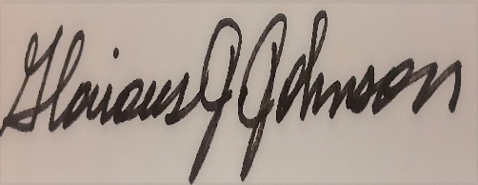
Honorable Glorious J. Johnson
GJJ/sys

